Wharfe Valley Archers Midsummer Shoot

(Incorporating the English, NCAS & Yorkshire Field Championships) 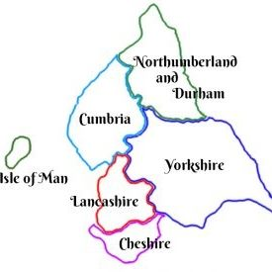
18th & 19th June 2022
Name | M/F | AGB Number  (Required) | Club | English  Club  Y/N | Yorks  Y/N | NCAS  Y/N | Age Group | Style | Peg  (red, blue, white) | Fee £ | Payment type:  Paypal or BACs
Contact details: _________________________________________________________________________________________________________
_________________________________________________________________________________________________________
Email: _____________________________________________________________________________________________
Signature of Consent of Parent/Guardian for child to undergo drug testing if required:__________________________________________________________
Privacy Notice: When you enter this competition the information you supply may be shared with tournament organisers, scoring systems, national and regional governing bodies and published on target lists and results. By completing this entry form you agree that the information you provide will be used as described above.

