Wharfe Valley Archers
Midsummer Shoot 20th & 21st June 2020 (inc. English Champs)
Important Information
As this shoot may be new to some of you, we thought it useful to give you some information prior to your arrival.
When arriving at the venue please ensure that you enter via the entrance shown below in the photos. Your satnav may take you to another entrance or one of the farms on the estate. If you don’t see this entry with the gate house then you are not where you should be!
VERY IMPORTANT! There are two Farnley Halls (and two Farnleys!) in the Leeds area – you’re heading for the one just outside of Otley! (LS21 2QF)
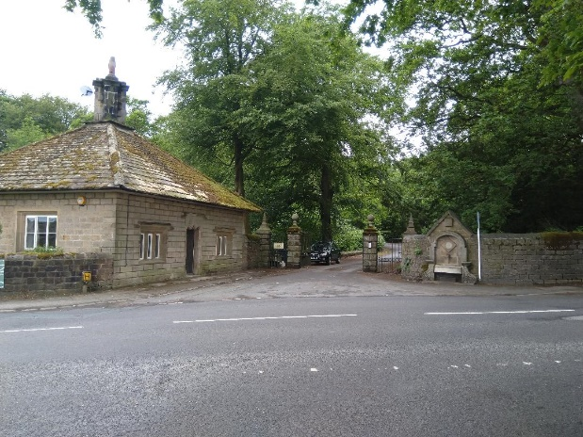
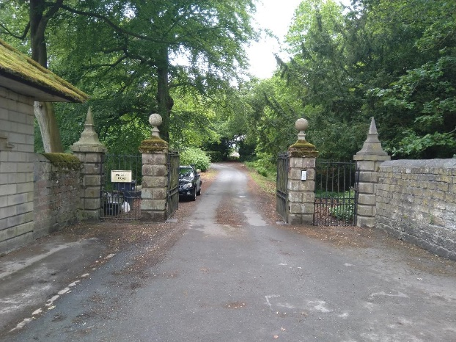

Once through the entrance please follow the signs to the course. The track to the course is approximately 900m long and should be accessible to all vehicles (unless you arrive in a low slung Ferrari or Lamborghini, in which case enjoy the wonderful walk down the track though the stunning woodland whilst your butler carries your kit). The first 100m or so is a little bumpy but if you can get to Overton via their farm tracks you will not have a problem. Likewise it is infinitely better than the track down to Dearne Valley. We’ve had a Nissan Leaf down the track only 2 weeks ago with no problems whatsoever. Please keep your speed to 5-10 mph and follow the parking directions.
Both the track and verges where you will be parking have a concrete base so although it looks like you’re driving and parking on soil, you will not sink! Please follow the parking instructions to avoid problems leaving at the end of the shoot.
The landowner will be around on both days so it is imperative that we make a good impression upon him particularly as this is our first shoot and we hope to hold more in the future.
Clothing: We are very lucky that our shoot is in pristine woodland. Unfortunately this also means that there are, in places dense patches of nettles and brambles. Whilst we have done our best to clear as much as we can from the paths around the course, it is recommended that you do not wear shorts.
Insects: There are a lot! Insect repellent is strongly advised.
Toilet facilities: Due to our location, toilet facilities are basic, therefore you know what to do before you set off!
Catering: As mentioned on the application form the catering will be very light – snacks and cold drinks ONLY. Please make sure you bring your lunch with you.
Medals will be according to entry for the Wharfe Valley shoot and the English Championships.
We look forward to seeing you all.

